Why become an accredited social enterprise?
Key benefits of gaining Social Enterprise Mark accreditation
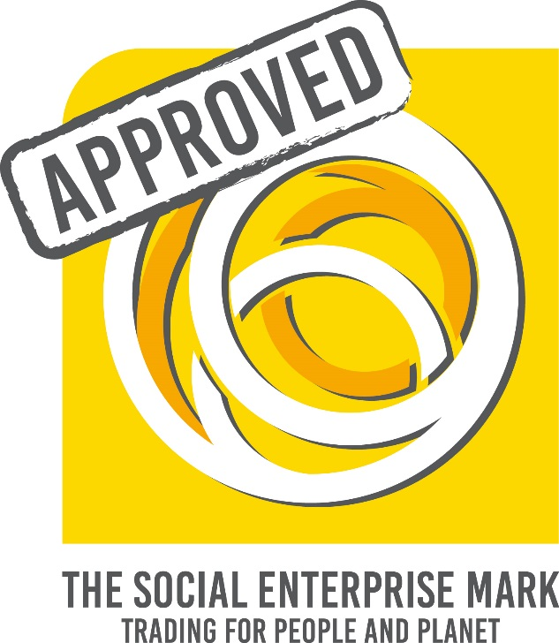

Prove your credibility
Prove your social enterprise credentials, by submitting to the scrutiny of a rigorous external assessment process. With annual checks against criteria, you can engage with and assure stakeholders that you are operating ethically, commercially and upholding sector-agreed standards.

The Social Enterprise Mark is the only accreditation to independently assess organisations against sector-agreed criteria to provide a guarantee of a commitment to trading for the primary benefit of people and planet.
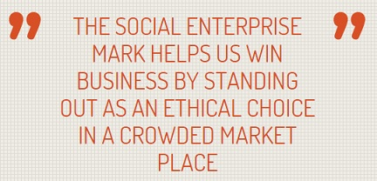

Articulate your social impact
We offer tailored support and guidance to applicants and renewing Mark holders in articulating their social impact. We provide detailed guidance in responding to how your organisation meets Criterion F of the Social Enterprise Mark: 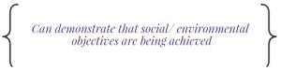
Our social impact questions are designed to help you think about the social impact you create, and to communicate this clearly and succinctly. We also create a Social Impact Declaration for all Mark holders, to summarise how you are striving to make a difference and standing up to scrutiny of purpose as a social enterprise. We also publish statements of how you commit to make a difference (social value).

Differentiate from competitors
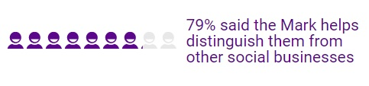
Stand out from competitors, by demonstrating you have been scrutinised against robust accreditation criteria, and have proven that your organisation puts people and planet before the interests of shareholders.

Statistics from 2016 Social Enterprise Mark CIC stakeholder survey

Approved social enterprise status
80% of social enterprises use their social enterprise status in marketing their products and services* – the Social Enterprise Mark can help with this.

Create buyer/partner confidence – displaying the Social Enterprise Mark lets them know you are truly giving back for social good.

*2017 State of Social Enterprise Report
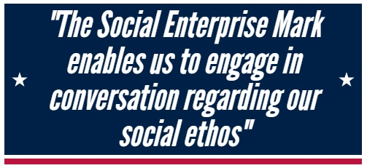

Get noticed as an approved social enterprise creating impact
Get featured in a unique directory that lists only accredited social enterprises and shows their social impact, which is viewed by approx. 400 visitors per month.
Social Enterprise Mark holders have their own profile on the directory, which includes details about the organisation with contact details and links to website and social media channels, as well as evidence of social impact. This will indicate your commitment to social enterprise principles as an approved Mark holder, as well as providing a public statement of how you commit to make a difference (social value).

Demonstrate good practice in social enterprise
Promote good practice and leadership in operating as a social enterprise, upholding sector-agreed standards and creating impact for the communities in which you operate and wider society.

Gain useful feedback
Our assessment feedback service* enables you to recognise how your organisation complies with the best practice criteria defined by the Social Enterprise Mark, and provides considerations for future development, including:
- How changes in governance or sources of income may affect your eligibility
- How you are reporting on distribution of profits
- How you are reporting on impact created for social beneficiaries
*Feedback is given after initial applications and 3 yearly full reviews.

Collaboration and networking
We facilitate collaboration amongst our international network of social enterprises and encourage Social Enterprise Mark holders to work in partnership to create combined social value.

Mark holders have access to networking and peer learning opportunities at our annual conference, with a varied and interactive programme to stimulate debate and learning, including a half day forum exclusively for Mark holders to share knowledge and good practice.
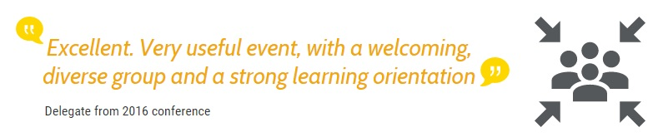

Exclusive tools and resources
We are pleased to offer our Mark holders support in communicating their social enterprise credentials and to maximise the impact of their Social Enterprise Mark accreditation.
Mark holders have access to exclusive resources to take full advantage of their status as independently guaranteed social enterprises, including free flyers and marketing toolkits and templates.

Hear what Social Enterprise Mark holders have to say

Next steps
